IP ADRESSES:



(Fig.1-IP Addresses format)



(Fig.2- Special IP Addresses)



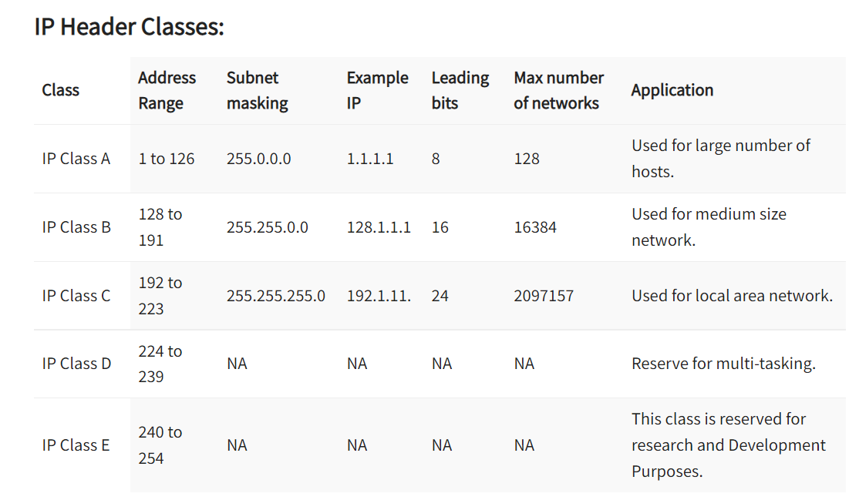

(Fig.3-IP Header classes)



Subnets:



(Fig.4-A campus network consisting of LANs for various departments)







(Fig.5-A class B network subnetted into 64 subnets)



CIDR- Classless Interdomain Routing:



NAT-Network Address Translation:



(Fig.5-Placement and operation of a NAT box)

